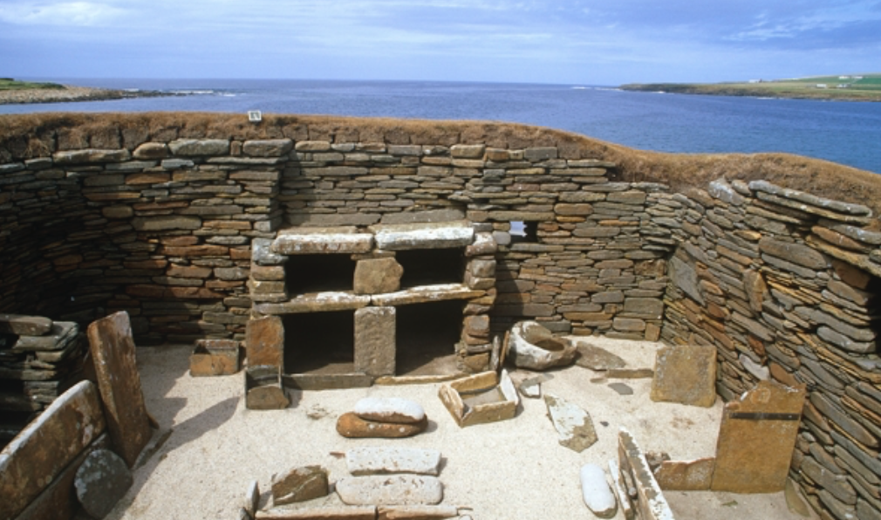  Literacy/ Spelling/ Phonics  Fiction “A Twist in the Tale”  Characterisation, traditional tale features. Story writing  Adjectives, irregular past tenses, nouns, verbs and adjectives  Poetry “A Closer Look” Poetic language. Identifying adjectives and verbs in poems. Compound nouns, noun phrases, the progressive form of verbs  Draft, edit and compose own poems  Non-Fiction  Does Chocolate grow on trees?  Explanation text features. Plan and write own explanation texts based on model  Adverbs. Suffixes ful, less, ness  Stone Age Boy-Making predictions from details stated and implied. I am learning to identify how structure, presentation and punctuation can contribute to meaning. Exploring character through drama. Expanded noun phrases. Write a description using expanded noun phrases.  Visit from James Carter author and poet | Mathematics White Rose planning Y2  Daily practice-mental maths, problem solving and method rehearsal  Money-Count money-pounds and pence. Choose notes and coins. Make the same amount. Compare amounts of money. Calculate with money. Make a pound. Find change  Multiplication- Recognise, make and add equal groups.  Introducing the multiplication symbol and multiplication sentences.  Arrays, equal groups-grouping and sharing  Length and height-Measure in centimetres. Measure in metres. Compare and order lengths and heights. Four operations with lengths and heights.  Mass, capacity and temperature-Compare mass. Measure in grams. Measure in kilograms. Four operations with mass. Compare volume and capacity. Measure in millimetres. Measure in litres. Four operations with volume and capacity. Temperature  Weekly addition and subtraction practice with 2-digit numbers  Computing-Programming:Sequencing Sounds (Scratch) | Science- Animals including Humans  Looking at animal young and comparing them to their adults. Exploring how animals change as they grow up.  Finding out about the life cycles of several varied common animals, including humans. Looking in detail at how humans change as they grow older, drawing on their own observations. Children are introduced to the three basic needs of animals for survival (water, food and air). Needs and Wants game. Making bird feeders. They will apply this knowledge, alongside research from secondary sources, to suggest ways to look after pets. The unit ends with children looking at healthy lifestyles, including the importance of exercise, healthy eating and hygiene. Keeping food diaries. “Gas” experiment! These healthy living lessons develop ‘working scientifically’ skills through investigating the impact of exercise on our bodies and how handwashing is essential for good hygiene.  Recapping Everyday Materials and their Uses topic with a Humpty Dumpty investigation
Geography/History  History-Stone Age to Iron Age.Was Stone Age man simply a hunter and gatherer, concerned only with survival? Concepts: Similarity and difference/change/ Old and Middle Stone Age. Focus on hunter-gatherer lifestyle. Case study Star Carr for evidence.How different was life in the Stone Age when man started to farm? Concepts: similarity and difference What can we learn about life in the Stone Age from a study of Skara Brae? Enquiry based on images of the remains of buildings Why is it so difficult to work out why Stonehenge was built? Content Focus on Bronze Age:how, where, when and why Stonehenge was built How much did life really change during the Iron Age and how can we possibly know? Concepts: enquiry using evidence to test an interpretation. Case study Danebury Can you solve the mystery of the 52 skeletons of Maiden Castle? Source-based history mystery Concepts: Using evidence, piecing together clues Content: Existence of different Celtic tribes across Britain Roman invasion AD43  Geography –  Geographical skills and Fieldwork Use maps, atlases, globes and digital mapping. | Cambo First School-Stone Age to Iron Age  Year 2  Books-Don’t Read This Book! Maximus and the Beanstalk. Growing Chocolate. Poetry by Joan Poulson, Moira Andrews and Grace Nichols. Stone Age Boy by Satoshi Kitamura Michael Morpurgo-The Puffin Keeper  Outdoor Learning/ Forest School-  Making bird feeders. Survival-making a solar still  Continuing to learn to identify different trees in our school environment.  Visit-“Ancient Britain”-den building, fire lighting, survival skills | Expressive Art  Art – linked to the theme of identity and The Linking Project  Visit to Laing Art Gallery  Replicating different ways to make pottery  Replicting a bronze casting method and iron smithing. Researching and experimenting with different materials.  Music  Mrs Hedley Planning  Violin/composition/ music appreciation  Mrs Anderson Friday 20 mins untuned/ tuned instrument and singing
PSHE/ RE  Jigsaw- PSHE -Dreams and Goals/Healthy Me (linked to The Linking Network PSHE on Identity) Discovery RE – Enquiry questions: Passover:How important is it for Jewish people to do what God asks them to do? The 8 Fold Path: Can the Buddha’s teachings make the world a better place? Easter: Salvation: Is forgiveness always possible for Christians? | PE  Gymnastics :Mrs Armstrong  Dance-Michelle Hankinson  Swimming Ponteland Instructors  Yoga Debbie McAllister | Design Technology  Levers and linkages  Recapping our Rainforest learning by designing a poster to promote awareness of the need to save the World’s rainforests. The poster will incorporate a mechanical system using levers and linkages.

