Literacy/ Spelling/ Phonics  Fiction “Christophe’s Story” Use discussion, role play and drama to understand more about the characters. Recall and summarise ideas. Draw inferences from a text. Explore author’s use of language; her choice of memorable words and phrases. Draw on understanding of conjunctions, adverbs and prepositions to express time and cause in oral recounts. Turn these into written recounts. Write a letter from Christophe to David using questions to develop ideas and rehearse orally. Plan and write a personal story about something that has happened to them. Apostrophes for possession. Determiners. Consolidate singular and plural Non-fiction Wanted: Space Explorer. Selecting applicants to be trained as astronauts for a mission to Mars! Reading about Neil Armstrong to find out good personal qualities to be an astronaut. Focus on effective use of pronouns and fronted adverbials. Use these in our two writing tasks: a diary entry and a biography. Adverbials of place. Revising fronted adverbials. Adverbials of Time. Determiners. Possessive pronouns. Revising capitals.  Poetry Exploring a range of poems, focusing in depth on the work of Grace Nichols and James Carter. Planning, rehearsing and performing a choral reading of a poem. Learning about personification, simile and metaphor, including these in our poems.  Exploring the patterns of rhyme and rhythm in shape and syllabic poems, reading cinquains and then creating our own. Watching and evaluating performances, using mind map descriptions and stories to create poems. Standard and non-standard verbs  MFL-Recap greetings/talking about myself and animals. Recognise, recall and spell up to ten instruments in French with the correct definite article/determiner. Start to understand articles/determiners better in French. Learn to say and write ‘I play an instrument’ in French using the high frequency 1st person regular verb ‘je joue’ (I play) with up to ten different instruments.  Visit from James Carter author and poet | Mathematics White Rose planning Y4  Multiplication and division-The 3, 6 and 9 x tables +division facts. 7, 11 and 12 times tables.  Multiply by 1 and 0. Divide a number by 1 and itself.  Multiply 3 numbers Related calculations, reasoning about multiplication. Factor pairs, using factor pairs, multiplying and dividing by 10 and 100. Informal written methods for multiplication. Multiply a 2 and 3 digit number by a 1 digit number. Divide a 2 and 3 digit number by a 1 digit number. Correspondence problems. Efficient multiplication  Length and perimeter-measure in kilometres and metres, equivalent lengths (kms/ms) Perimeter on a grid and of a rectangle. Perimeter of rectilinear shapes and polygons  Fractions and decimals-understanding the whole, partition a mixed number, compare and order mixed numbers, understanding and converting improper fractions. Equivalent fractions. Adding and subtracting fractions. Tenths and hundredths  Daily practice-mental maths, problem solving and method rehearsal  Computing-Programming:Sequencing Sounds (Scratch) | 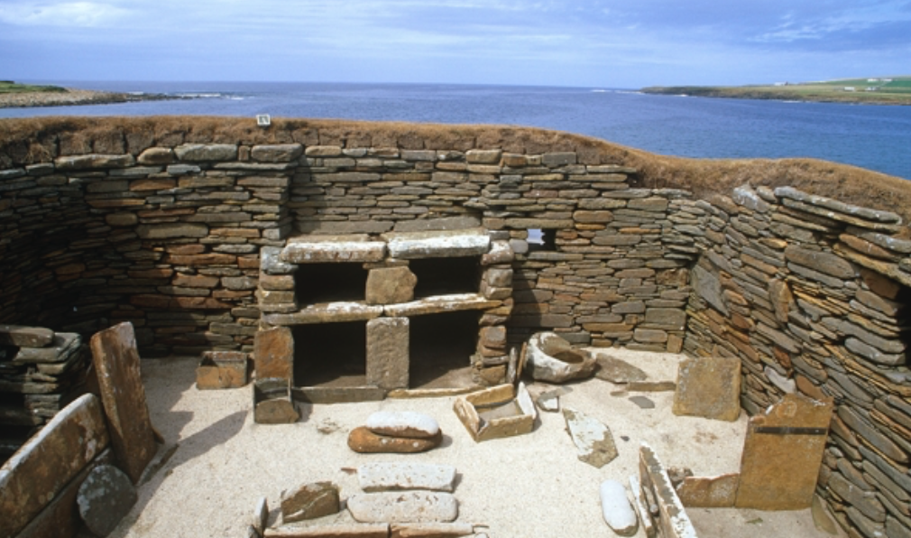  Science- Animals including Humans  Expanding learning from year 3 about how animals, including humans, need to get nutrition from what they eat.  Exploring the different organs of the digestive system in humans and the functions of teeth in both humans and animals. Learning about the different types of teeth and the importance of good dental hygiene, Planning and carrying out an investigation into tooth decay using an egg as a model tooth.  Learning about the parts and functions of individual organs of the human digestive system and carry out their own scientific demonstration of the process using everyday household items.  Learn about herbivores, carnivores and omnivores in the context of teeth, digestion and food chains. Extend understanding of food chains from key stage 1 to include more complex chains, using the terms ‘consumers’ and ‘producers’ and compare food chains in different habitats. Finally, children will compare the teeth of different types of animals and apply their understanding to make links with their role in the food chain.
Geography/History  History-Stone Age to Iron Age.Was Stone Age man simply a hunter and gatherer, concerned only with survival? Concepts: Similarity and difference/change/ Old and Middle Stone Age. Focus on hunter-gatherer lifestyle. Case study Star Carr for evidence.How different was life in the Stone Age when man started to farm? Concepts: similarity and difference What can we learn about life in the Stone Age from a study of Skara Brae? Enquiry based on images of the remains of buildings Why is it so difficult to work out why Stonehenge was built? Content Focus on Bronze Age:how, where, when and why Stonehenge was built How much did life really change during the Iron Age and how can we possibly know? Concepts: enquiry using evidence to test an interpretation.Case study Danebury Can you solve the mystery of the 52 skeletons of Maiden Castle? Source-based history mystery Concepts: Using evidence, piecing together clues Content: Existence of different Celtic tribes across Britain Roman invasion AD43  Geography –Recap Europe map work and place names.  Geographical skills and Fieldwork Use maps, atlases, globes and digital mapping. | Cambo First School-Stone Age to Iron Age  Year 4  Books-Christophe’s story by Nicki Cornwell. Collected poems by James Carter and Grace Nichols. Wanted: Space Explorer-e-book. Stone Age Boy by Satoshi Kitamura Michael Morpurgo-The Puffin Keeper  Outdoor Learning/ Forest School-  Visit-“Ancient Britain”-den building, fire lighting, survival skills Exploring different ways to make fire. Design a safe and fair experiment to see whether magnesium helps light fires. Grinding flint experiment.  Continuing to learn to identify different trees in our school environment. | Expressive Art  Art – Linked to the theme of identity and The Linking Project  Visit to Laing Art Gallery  Replicating different ways to make pottery  Replicting a bronze casting method and iron smithing. Researching and experimenting with different materials.  Music  Mrs Hedley Planning  Violin/composition/ music appreciation  Mrs Anderson Friday 20 mins untuned/ tuned instrument and singing
PSHE/ RE  Jigsaw- PSHE -Dreams and Goals/Healthy Me (linked to The Linking Network PSHE on Identity) Discovery RE – Enquiry questions: Passover: How important is it for Jewish people to do what God asks them to do? The 8 Fold Path: Can the Buddha’s teachings make the world a better place? Easter: Salvation: Is forgiveness always possible for Christians? | PE  Gymnastics :Mrs Armstrong  Swimming Ponteland Instructors  Dance-Michelle Hankinson  Yoga Debbie McAllister | Design Technology  Levers and linkages  Recapping our Rainforest learning by designing a poster to promote awareness of the need to save the World’s rainforests. The poster will incorporate a mechanical system using levers and linkages.

