Literacy/ Spelling/ Phonics  Fiction “Dragon Slayer” Explore and compare legends looking at plot and features. Recall and retell main events. Use drama to explore characters and dilemmas. Plan, edit and write own legends. Conjunctions. Adverbs of Time. Prepositions  Poetry Shape poems. Calligrams. Word play. Comparing poems. “Brown Owl and “Bug Hug” by James Carter. The Allivator by Roger McGough.  Non-fiction “Where would you like to live?” Retrieve and collate information about different countries and similarities and differences between the lives of children around the world. Presenting information using paragraphs and headings. Compose a report to say where they would like to live. Conjunctions  French  J’apprends le français. Je peux (verbs) Les formes  Introducing greetings, colours, numbers and seasons/weather | Mathematics Autumn planning /White Rose  Place Value in 3-digit numbers-number lines/ Base 10/place value counters. Flexible partitioning. Comparing and ordering. Estimating  Roman Numerals (introduction) Adding and subtracting 1s, 10s, 100s . Add two 2- and 3-digit numbers with and without exchange. Subtract two 2- and 3-digit numbers with and without exchange. Find the difference/Efficient subtraction. Estimating and checking. Inverse calculations. Multiplication and Division: 4, 8 times tables. Recap 3s and 2s,5s,10s. Count in multiples of 4, 8, 50 and 100. Sharing and grouping (Y2 consolidation)  ICT. The Internet. Recognising the internet as a network of networks including the WWW and why we should evaluate online content. Audio production: making a podcast | 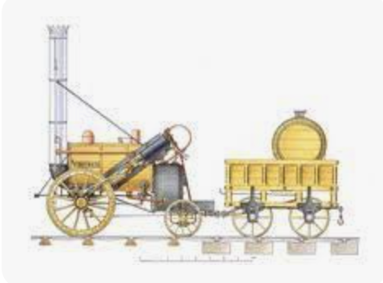  Science  Rocks  Describing the features of different rocks. Classifying rocks based on their features. Comparing and grouping together different kinds of rocks on the basis of their appearance and simple physical properties. Identifying sedimentary, igneous and metamorphic rocks  Describing how sedimentary/metamorphic rocks are formed. Naming sedimentary and metamorphic rocks. Testing for porosity/hardness. Making a metamorphic rock. Describing how igneous rocks are formed and giving examples. Making crystals. Intrusive and extrusive rocks. Describing what a fossil is, how it is formed and identifying as plant or animal.  Investigating soils and knowing they are made up of rocks and organic matter. Naming some types of soil and listing their properties  Crest Award Activities to complete passport
Geography/History  History: The Railway Revolution Exploring the technical developments that changed transport and travel during the Industrial Revolution. The introduction of the first steam locomotives and how this changed people’s lives since 1830. Local focus: The Wannie Line. National: how the development of underground railways changed the lives of Londoners.  Geography: Europe. Locating Europe on a World map. To be able to identify and locate countries in Europe. To know some features such as flags, currencies, landmarks. To able to identify major capital cities. To be able to compare two European capital cities. To find out about the human and physical features of a European country/France. | Railways/Europe  Y3 Books  Saint George and the Dragon/The Beast with a Thousand Teeth-ebooks James Carter Collected Poems Roger McGough Collected Poems “Where would you like to live?” Non-fiction books relating to countries. The Puffin Keeper Michael Morpurgo The Day I Fell into a Fairy tale Ben Miller  Visits/Outdoor Activities  Stephenson Steam Railway/Walking part of The Wannie Line  Deux Petits Oiseaux-Outdoor French  Rocks-outdoor activities related to science topic | Expressive Art  ART – What can art tell us about the climate and geographical features of a country? Focus on France. Cezanne, Morisot, Seurat. To use the artwork of Cezanne to infer what it tells us about the landscape and climate of Provence. What can it tell us about how the landscape has changed over time? To develop skills in using new techniques: Conte crayon sketching, pointillism and impasto. What can Morisot’s artwork tell us about the coastline of France and how it has changed over time? Alma Thomas-extension of pointillism. Sonia Delauney  MusicMrs Hedley: violins, composition, notation  Mrs Anderson Friday 20 mins untuned/ tuned instrument and singing/ peripatetic teaching.
PSHE/ RE  Jigsaw-Being Me in My World/Celebrating Difference  Re –Christianity: What did Jesus teach? Enquiry Question: Is it possible to be kind to everyone all of the time? Christmas: Jesus as gift from God Concept: Incarnation. Enquiry Question: Why do Christians believe God gave Jesus to the World? | PE  Dance Michele Hankinson/ Yoga  Swimming Ponteland Instructors  Tag Rugby  Cricket  Mrs. Armstrong-skills | Design Technology  The Great Bread Bake Off-researching the history of a company (Warburtons), taste testing and creating a new flavour bread bun.

